Submission #: 0000

Demo Title: XXXX

Authors: ???, ???, …

Brief Description of the Demo Layout: (Sample Description) This demo requires a desk for us to place our components onto (i.e., Google Cardboards, smartphone, controller prototypes, monitor) and a space for attendees to try the demo. Only the participant’s head movement and the controller will be tracked. Therefore, we only require enough space for the participant to freely extend and move their arms. We estimate this to be 3m by 3m. If possible, we would like a monitor that can be connected to our personal laptop to display the screen of the smartphone in the Google Cardboard so other attendees can view the current demo live while not participating in the demo. If this isn’t possible, we can transport our own monitor.

Layout Sketch: Please include a sketch of the demo layout with the size in meters
(Sample Sketch)
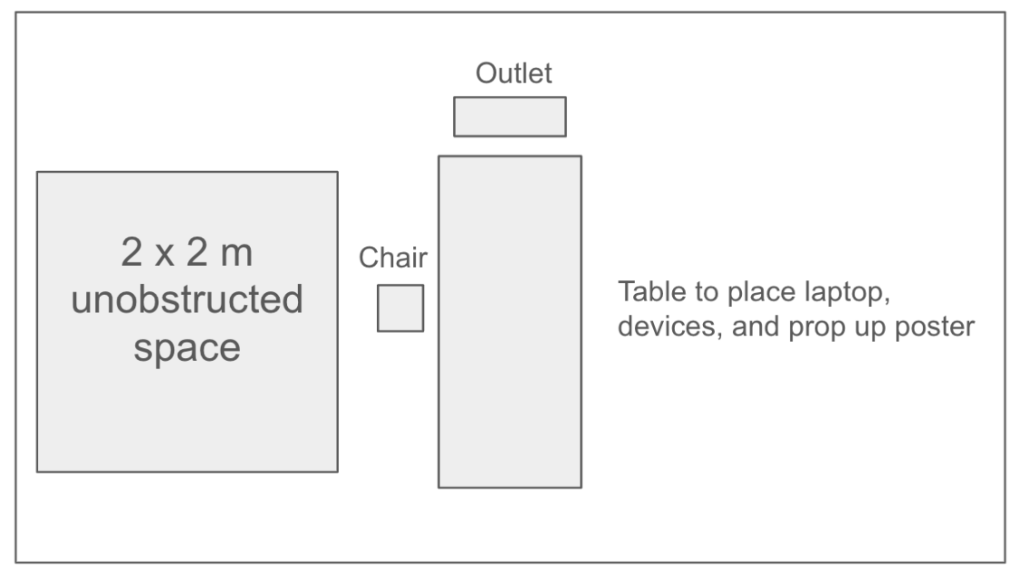

Devices to Bring:
- Laptop
- HDMI cable
- Power Strip
- Projection Equipment
- Power Outlet
- Screen + Stand

Additional Notes to Share with the Demo Chairs:
………
………

*** The authors of the accepted demos will need to communicate and finalize the layout as the details of the demo space are confirmed later.

